Online Learning – Golden Rules

1. I will listen carefully to the adult speaking and unmute only when asked.

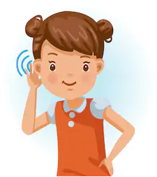 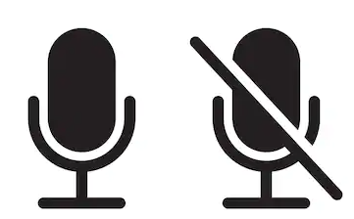

1. I will be polite and use kind words, both spoken and typed.

 

1. I will behave the same way I do in class: be fully dressed (not pyjamas), sit sensibly (not in bed) and avoid eating on a live call.

  

1. I will only use my school Teams login for school work and school meetings.

 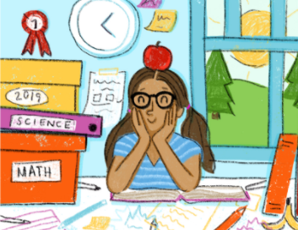

1. I will not interrupt my brother or sister’s learning or meetings.

 

Keep up the great work – we miss you!