 | Evidencing the Impact of Primary PE and Sport Premium 2019-20
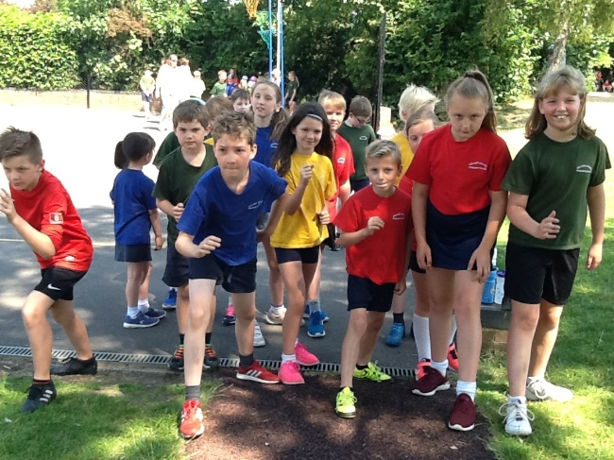 | 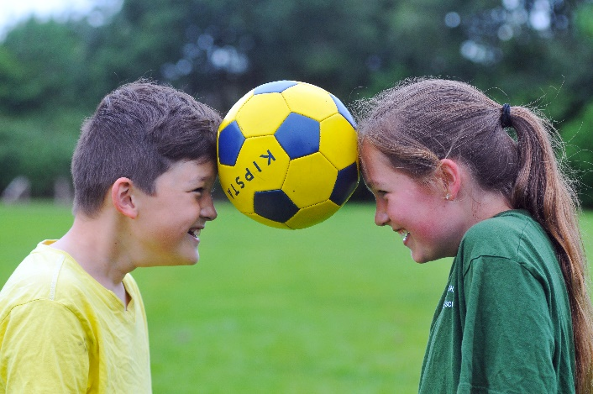 | 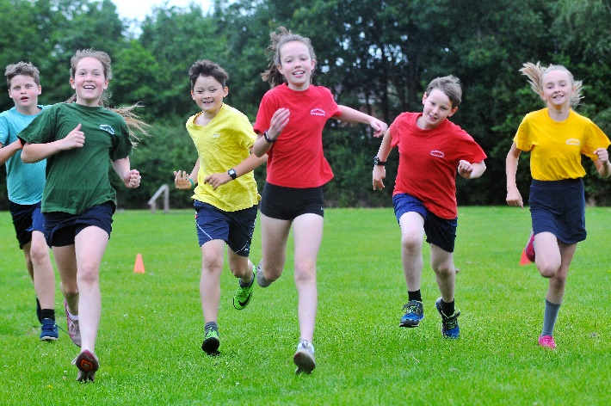
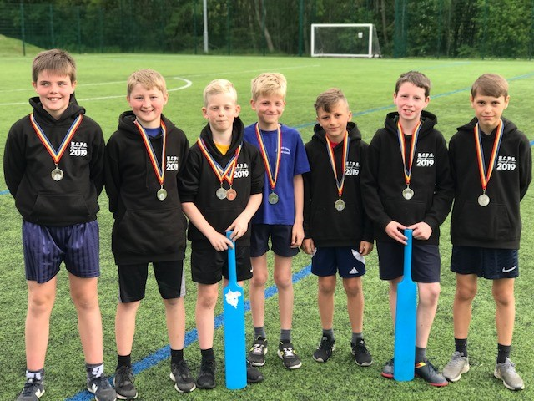 | 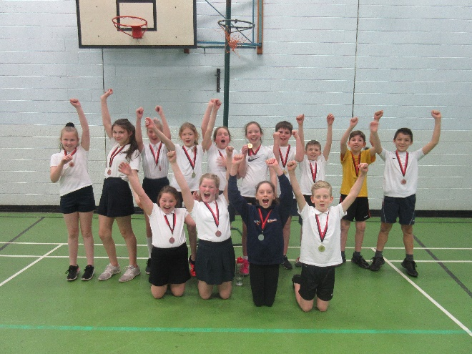 | 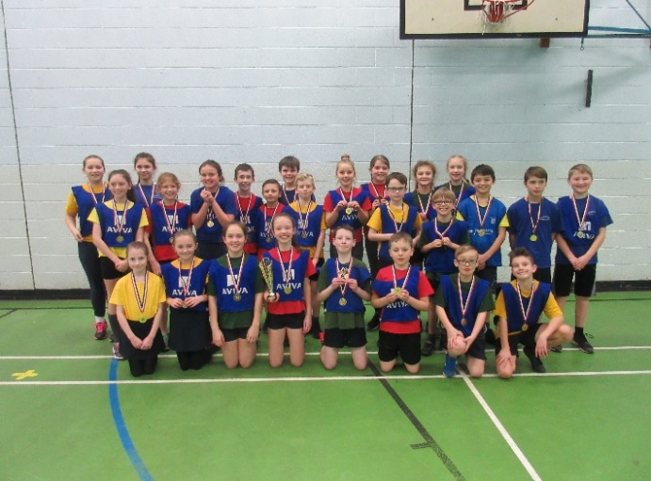

Key achievements to date: | Areas for further improvement and baseline evidence of need:
- Range of activities available to children within school which promote goal setting and growth mindset.  - Continuation of Sports Ambassadors to promote good role models and create a legacy within HCPS.  - Participation in cluster sports competitions.  - Second successful Christmas run- whole school Christmas charity even.  - Intra school competitions to provide a level of competition for all children across the entire school.  - Increased the amount of swimming lessons provided to reduce the amount of catch up swimmers (long term target). | - Implement a successful and effective planning scheme which will enhance our PE curriculum.  - Increase the amount of children participating in before/after school clubs.  - Improve swimming data, making sure our children leave KS2 meeting NC objectives (see below).  - Build links with local companies and sports clubs to provide more opportunities for pupils.  - Set up and run a Sports blog/ website page for match reports and updates.  - Research training opportunities for staff- swimming training/qualifications  - Develop links with local newspaper  - Work towards achieving Bronze or Silver School Games Mark Award

Meeting national curriculum requirements for swimming and water safety | Please complete all of the below:
What percentage of your current Year 6 cohort swim competently, confidently and proficiently over a distance of at least 25 metres? | 80%
What percentage of your current Year 6 cohort use a range of strokes effectively [for example, front crawl, backstroke and breaststroke]? | 74%
What percentage of your current Year 6 cohort perform safe self-rescue in different water-based situations? | 43%
Schools can choose to use the Primary PE and Sport Premium to provide additional provision for swimming but this must be for activity over and above the national curriculum requirements. Have you used it in this way? | Yes

Academic Year: 2019/20 | Total fund allocated: £19710 | Date Updated: 14/04/20
Key indicator 1: The engagement of all pupils in regular physical activity – Chief Medical Officer guidelines recommend that primary school children undertake at least 30 minutes of physical activity a day in school |  |  |  | Percentage of total allocation:
 |  |  |  | 21.4%
School focus with clarity on intended impact on pupils: | Actions to achieve: | Funding allocated: | Evidence and impact: | Sustainability and suggested next steps:
Increase physical activity within lessons and during playtime.  Improve our approach to swimming to make sure a higher percentage of our Year 6 children leave KS2 meeting NC objectives. | Golden mile- Premier Sports scheme which involves children running around the track (trim trail) and laps counted and converted into miles. | £1148 | Improvements in fitness and gross motor skills these will also bring an expected improvement in concentration levels and fine motor skills in the classroom.  Children given the opportunity to develop their cardiovascular fitness and growth mind-set. Children can achieve goals and data has shown an increase of whole school improvement. Higher level children are recognised immediately from the amount of laps they can run without stopping. This has also helped promote emotional well-being within school. | Next steps - to continue to promote the scheme next year and celebrate those who achieve mile stones.  Evaluate appropriateness for SEND children. Find ways to adapt data collection for those children with special needs.
 | Updated equipment for EYFS including PVC Footballs and balancing boards. | £30  £312 | EYFS equipment updated to provide opportunities for children to practice their balance and fundamental movement skills during ‘choosing time’. | Monitor next year and discuss effectiveness with EYFS staff.
 | Transport provided to reassess our Year 5/6 children and increase the amount of children who go swimming across the year.  - Autumn term  - Spring term  - Summer term | £1344  £1380  COVID

Key indicator 2: The profile of PE and sport being raised across the school as a tool for whole school improvement |  |  |  | Percentage of total allocation:
 |  |  |  | 5.1%
School focus with clarity on intended impact on pupils: | Actions to achieve: | Funding allocated: | Evidence and impact: | Sustainability and suggested next steps:
Promote HCPS school approach to PE & Swimming.  Increase engagement and enjoyment of participating in Physical Activity.  Use PE as a vehicle to support the whole school ethos.  Promote healthy living and fitness. | Communication with the school community:  - Match reports from competitions are regularly published in school newsletter (sent out via Parent mail to every parent).  - Announcing results of each competition within whole school assemblies.  - All certificates/medals are acknowledged during celebration assemblies. | £0 | Parents have commented that they like reading match reports, especially when written by Sports Ambassadors. | Easily sustainable and has now become a HCPS tradition. Next steps are to appear in the local newspaper and reach out to local companies to try and promote PE at HCPS outside the school grounds.
 | Display in KS2 corridor - all team photos from competitions or sporting events are displayed on sports notice board in school reception. | £0 | For visitors, acknowledges our sporting achievements and highlights are continual work to provide children with opportunities to compete against other schools in the local area. | Continue next year. Also start uploading team photographs onto the website regularly.
 | Staff running club | £0 | Staff providing great role models for children, taking part in physical activity after school to keep fit and healthy. Initiative brought upon to promote emotional wellbeing. | Continue next year, but seek out opportunities to take the club running outside of school to running events.
 | Additional equipment was ordered to support the delivery of High Quality PE.  Updated sports equipment-  - Netball balls and bibs/ hockey stick rack, tennis balls, badminton kits, handball kits  - Sports whistles  - Foam cones | £979  £5  £15 | Replacing balls with no grip or have been damaged has promoted PE has the children are looking forward to use brand new tennis balls etc. The foam cones were brought to promote game based activities during lunchtimes. Sports whistles were purchased to promote pupils to umpire and lead activities/games during lesson time.  New equipment has been purchased ready to teach new sports/skills in Sept 2020. | Monitor PE equipment and replace anything which is broken or needs replacing.
 | Head Teacher kept fully aware of progress in PE and school sport and close monitoring of the impact of the PE and school sports Premium (business manager). | £0 |  | Communication to continue next year.

Key indicator 3: Increased confidence, knowledge and skills of all staff in teaching PE and sport |  |  |  | Percentage of total allocation:
 |  |  |  | 5.6%
School focus with clarity on intended  impact on pupils: | Actions to achieve: | Funding  allocated: | Evidence and impact: | Sustainability and suggested  next steps:
Continue to support staff confidence, competence and subject knowledge through CPD and improved access to resources.  Implement the PE Passport as a scheme of work across entire school. | Continue to audit and replenish PE equipment, using the play leaders, sports coaches (Premier Sports) and staff to identify need for new equipment. | £0  (Equipment costs already mentioned above). |  | Extend knowledge and understanding by continuing to train staff in areas of PE (swimming and gymnastics).  Subject leader to team teach and observe lessons.
 | Timetables carefully planned to ensure minimum of 2 hours high Quality PE for all classes. | £0 | Children allocated 1 hour of inside PE (within the hall) and 1 hour outside. This promotes regular physical activity and becomes part of the weekly timetable for each class. | Continue next year.
 | Investment in PE Passport planning  - Annual subscription  - Two IPads and cases to allow accessibility to new planning scheme. | £500  £307  £295 | This new planning has been trialed by selected year groups and is now ready to implement in September 2020. | Monitor and promote use of planning to enhance our PE curriculum.
 | Purchased one copy of ‘Safe Practice in Physical Education and School Sport’ | £3 | This has become our ‘go to’ book for Health and Safety regulations.

Key indicator 4: Broader experience of a range of sports and activities offered to all pupils |  |  |  | Percentage of total allocation:
 |  |  |  | 1%
School focus with clarity on intended  impact on pupils: | Actions to achieve: | Funding  allocated: | Evidence and impact: | Sustainability and suggested  next steps:
To provide opportunities for children to experience a wide range of sports and activities.  Widen the experiences offered to children within school  Continue the successful programme of extra-curricular activities and develop for specific groups (KS2 girls). | Weekly indoor and outdoor clubs provided and arranged by Premier Sports, Shooting Stars Football and staff members. | £0 | Numbers of each club seem high. Children enjoy participating in the clubs both before and after school. | Promote staff to run clubs next year to provide even more opportunities for children within the school grounds.  Continue to advertise and promote a range of extra-curricular activities using pupil voice as a vehicle.  Use local clubs and companies to improve community links and offer alternative out of school activities to our pupils.
 | Provide specialist coaches to run after-school girls multi-sport KS2 club every term. | £195 | Very popular club which allows KS2 girls to participate in sport within a more comfortable environment for them. | Continue to provide provision next academic year.

Key indicator 5: Increased participation in competitive sport |  |  |  | Percentage of total allocation:
 |  |  |  | 22.5%
School focus with clarity on intended  impact on pupils: | Actions to achieve: | Funding  allocated: | Evidence and impact: | Sustainability and suggested  next steps:
Continue to engage fully in inter-school competitions within the Sandbach cluster; many of which taking ‘A’ and ‘B’ teams.  Allow opportunities for children to participate in competitive sports against other schools with the MAT.  Give every child within HCPS the opportunity to compete during PE sessions each term. | Work with Holmes Chapel Comprehensive and attend meetings with cluster schools in order to arrange and participate in cluster competitions throughout the year. | £4350 EIP Sports Contribution  £80 Affiliation charge | Children enjoy and are proud to represent HCPS at competitions. We take as many competitors | Continue to liaise with Trevor Capewell (PE co-ordinator of Holmes Chapel Comprehensive).  Inform children of local clubs they could join, by displaying posters around school.
 | Class verses class competition- each year group holds competitions between classes at the end of each term based on what they have been learning in class. | £0 | Promotes competitive sports within school. Every child takes part in competitive element and learn key sportsman/woman skills (team work, motivating others, encouraging others, working for a goal). | Continue next year to promote participation in competitive sports across the entire school.
 | Teachers to continue to support the delivery of inter-school sports competitions. | £0 | Teachers very flexible when it comes to competitions, allowing extra pre-match training to take place during school time. | Encourage other members of staff to come and support children when competing locally.

Under spend amount to be carried forward into 2020/21 (due to Covid 19)
£9142

Where schools are carrying forward under-spends, their published online report should set out the amount being carried forward and give brief reasons for this under-spend:

- Unable to continue with paid for before/after school clubs
- Usual summer payment not made for Swimming sessions
- The purchasing of resources for and throughout the summer term
- Enrichment and leadership opportunities during the summer term
- Any purchasing of kit for following academic year
- Any purchasing of Enrichment and Golden Mile sessions for following academic year

