Maths – addition and subtraction (1)
These are the models which we would use with the children to represent
35 + 12 = 47

Part Part Whole
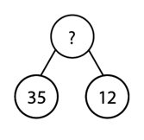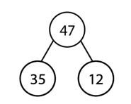
Bar Model
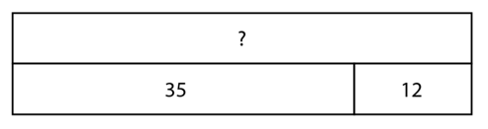

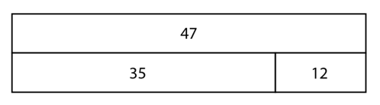

Moving on to representing this as a columnar addition:
